Ranger Telerobotic Shuttle Experiment:
Status Report

Gardell G. Gefke, Craig R. Carignan, Brian J. Roberts, and J. Corde Lane

Space Systems Laboratory, University of Maryland, College Park, MD 20742

ABSTRACT

This paper presents an update on the Ranger Telerobotic Shuttle Experiment (RTSX) and associated key robotics technologies within the Ranger program. Ranger TSX will operate from a Spacelab logistics pallet inside the cargo bay of the shuttle and will demonstrate space station and on-orbit servicing operations including extravehicular (EVA) worksite setup, an orbital replacement unit (ORU) exchange, and various task board experiments. The flight system will be teleoperated from the middeck inside the shuttle as well as from a ground control station at NASA Johnson Space Center. This paper addresses the technical and programmatic status of the flight experiment and describes progress on the engineering test unit, Ranger Neutral Buoyancy Vehicle II (RNBVII), currently in fabrication. Also described are associated technologies, which support this effort. These include a flight robot mockup built to practice EVA stowage and Ranger NBV I, a free-flight prototype vehicle.

Keywords: telerobotics, satellite servicing, neutral buoyancy, manipulator, remote operations

INTRODUCTION
The Ranger Telerobotic Shuttle Experiment, presented at SPIE’96¹ with updates presented in 1997² and 1998³, plans to demonstrate telerobotic serving of on-orbit systems during a mission on the Space Shuttle. The Ranger project is nearing completion of the second, fully functional, neutral buoyancy vehicle (RNBV II) of the program. Ranger NBV II acts as an engineering unit and mission operations planner/simulator, and establishes a ground simulation task database for comparison to orbital testing.
Dexterous robots of a Ranger class could potentially service attached experiments (such as on Shuttle or Space Station) and, with a free-flying base, stand alone satellites (such as geostationary communications satellites). The Ranger mission plans to use both shuttle and ground-based control stations. These act in a teleoperation (human-in-the-loop) mode with a few automated sequences for some routine sub-tasks. Commands and telemetry flow through the orbiter’s Ku-band shuttle communications links.
The experimental tasks range from simple, robotic manipulator characterization to complex human extravehicular activity (EVA)⁴. This will provide information on how to improve orbiting robots, and demonstrate increasing levels of robotic capability to augment human EVA servicing and setup. Performing these with both onboard and ground control allows improved calibration of ground simulation and a better understanding of the resource tradeoffs between space-borne or ground-based operators.
This experiment is sponsored by NASA’s Office of Space Science and is conducted by the University of Maryland through a cooperative agreement. The university connection has and continues to allow numerous young engineering students to get hands-on experience with a flight program. The first generation Ranger prototype, RNBV I, was designed and built largely with student effort. The Space Systems Laboratory at the University of Maryland also operates the Neutral Buoyancy Research Facility (NBRF) where Ranger and other lab telerobots are tested.
This paper begins by reviewing the Ranger mission objectives in Section 2. Section 3 describes the flight robot and its systems. Section 4 describes the Ranger NBV II. Section 5 details the software and control approaches. Section 6 highlights the control schemes available to the operators, and Section 7 gives an outlook on the future of the program.

EXPERIMENTAL OBJECTIVES
The RTSX program objectives address three main areas. The first is robotic characterization and task demonstration. These will validate the robot’s design for compatibility with the space environment, and show the utility of a telerobot to assist and augment humans in space servicing. The second is studying the human factors effects of controlling a highly dexterous robot from a variety of control station environments and configurations. The third provides a relevant correlation database to improve and refine neutral buoyancy simulations of telerobotic operations.

Characterization and Task Demonstrations
The four main task experimental areas are designed to build confidence in robotic servicing systems and to show their high utility to augment and expand human servicing of on-orbit assets⁵. Ranger will first carry out a series of trajectories and robotic science operations on a task board. These will calibrate the control gains and ensure the robot is operating within design parameters. The next two task levels involve replacing simulated components of existing orbiting systems. One is a single arm task designed for telerobots on the ISS, and the second is a simulated Hubble Space Telescope (HST) module designed for human EVA. The final task is setting up an Articulating Portable Foot Restraint (APFR) used by US astronauts when servicing the ISS or Shuttle cargo bay experiments.

Human Factors
The overall human factors science strategy seeks to isolate the effects of time delay, micro-gravity and simple vs. advance control interfaces^{6,7}. The flight crew will operate a control station with basic functionality, and can toggle on/off a simulated time delay. The ground control station, which always has time delay, can replicate the functions of the crew control station, and also has a range of additional monitoring and control inputs. These will help identify the areas most critical to improving space telerobotic control and operations. Astronauts on orbit are an extremely costly asset. Demonstrating successful ground-based telerobotic control has the potential to save significant resources while improving science and maintenance of the ISS or other satellites.

Correlation of Flight Data to Ground Simulations
The Ranger program requires several ground simulations to ensure a successful mission. These range from completely virtual computer simulations to neutral buoyancy simulation of the flight hardware. Performance data from all the simulations will allow a greatly improved correlation between ground simulators and actual flight operations. In turn, this leads to better assessment of future Ranger or other robotic systems on different missions or operations on the ground, potentially saving significant resources.

SYSTEM CONFIGURATION
The RTSX system configuration consists of a Spacelab Logistics carrier in the shuttle cargo bay holding the flight robot and task suite. A Flight Control Station, located in the shuttle middeck, allows the flight crew to control the robot, and provides data and video connections to the ground via the orbiter Ku-band communications system. A ground control station, located in the Payload Control Center (PCC) in the Mission Control Center (MCC) at NASA’s Johnson Space Center, allows ground operators to control the robot in real-time. Ranger NBV II is used in neutral buoyancy simulation at the NBRF on the University of Maryland at College Park (UMCP). The NBRF also has a control room and a ground simulator of the flight control station used for crew and ground operator training.

Cargo Bay Equipment
The cargo bay equipment consists of the flight Ranger robot, task equipment, and support equipment carried to orbit on a bare Spacelab Logistics Pallet (SLP).

Robot
The robot has a central body and four manipulators. A single, large diameter “leg” with six degrees-of-freedom (DOF) anchors the robot to the SLP and positions the body at the appropriate location for each task. The two dexterous arms, each with eight DOF and two tool drives, perform the hands-on task demonstrations. Their wrists can accommodate any of seven interchangeable hands/tools. Ranger uses interchangeable specialty hands/tools vs. a more complex hand capable of using different tools. The fourth manipulator is a stereo camera pair on the end of a seven DOF arm, allowing the operator to position these cameras to any desired camera view. Another stereo camera pair is located in the Ranger body, and both dexterous arms have wrist cameras.

Task Equipment
The task suite consists of four components. A robotic task board consists of spring plates, contours and small diameter holes. An RPCM, a module used on the ISS, is designed for replacement by a robot. The HST Electronics Control Unit is a module replaced by astronauts on a previous Hubble servicing mission, and was not designed for robotic replacement. The APFR is a human EVA deployed and used foot restraint. Its setup adds significant overhead time to current human EVA.

Support Equipment
The support equipment on the SLP includes the pallet floor secondary structure (PFSS), which holds the Ranger latch mechanism and acts as the foot anchor point for the robot. The PFSS allows the stowed robot to mount to the SLP as a single unit, greatly decreasing SLP integration effort. Two upper side orthogrid secondary structures are mounting planes for the task plates and the electrical power converter system.

Crew Cabin Equipment
The crew cabin equipment is located on the orbiter middeck. A double middeck locker houses the flight control station, which consists of the main CPU, hard drives, electrical conversion, video switching and downlink encoding. Three additional single lockers hold the four flat-panel LCD screens for computer monitor and video presentation, the keyboard and track ball, and the wire harnesses needed for power, Ethernet and video.

Ground Equipment
The ground equipment consists of a ground control station and monitoring station at the Johnson Space Center (JSC), and a monitoring station in the NBRF at the University of Maryland. The telemetry, video and commands to/from the ground control station from/to the flight control station and robot are routed through the Mission Control Center via the SpaceNet using TRDSS. A one-way telemetry/video data link from JSC to the University of Maryland, allows remote mission monitoring.

Ranger Neutral Buoyancy Vehicle II
The Ranger Neutral Buoyancy Vehicle II is the engineering test unit for Ranger TSX and will support development, verification, operational, and scientific objectives of the RTSX mission. The vehicle is anchored on a mockup of the Spacelab pallet at the bottom of the neutral buoyancy tank. It is used for micro-gravity simulation of all on-orbit operations. Planned manipulator motions are slow enough to minimize water drag effects, and the task elements are made neutrally buoyant to simulate weightlessness. However, it will be difficult to replicate the on-orbit lighting conditions, and external flotation may be required to make the manipulators and end effectors neutrally buoyant.

Robot
The RNBV II vehicle is identical to the flight robot with a few exceptions. See figure 2 showing a medium fidelity mockup of the RTSX configuration. RNBVII includes pressure seals and is supplied with pressurized air and electrical power from the surface since its mobility is much more limited than RNBV I shown docked to a satellite mockup in Figure 1. This allows submersion into the neutral buoyancy tank. Some commercial parts are substituted for the military or space-rated parts of the flight unit to reduce cost. A ground support station supplies the air and simulates the function of the DC-DC converters used by the flight unit. The task equipment is duplicated for use underwater. Modifications, such as adding foam to the interiors, are needed to operate for neutral buoyancy simulation. An APFR made of plastic instead of aluminum makes its simulation more accurate.
The robot body consists of the central “body” and “head”. The body houses the two main computers, power distribution circuitry, and acts as the anchor point for some manipulator launch restraints and the body latches. The head, attached to the front end of the body, serves as the mount for the four manipulators.

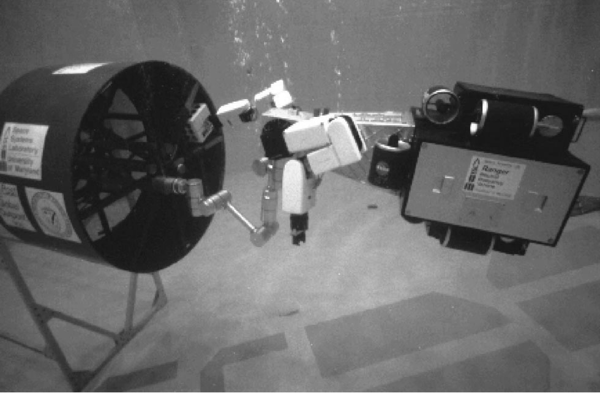Figure 1: Ranger NBV I removes an ORU with its right arm while grappled to satellite mockup at the Neutral Buoyancy Research Facility. (Note: Video arm not installed.)

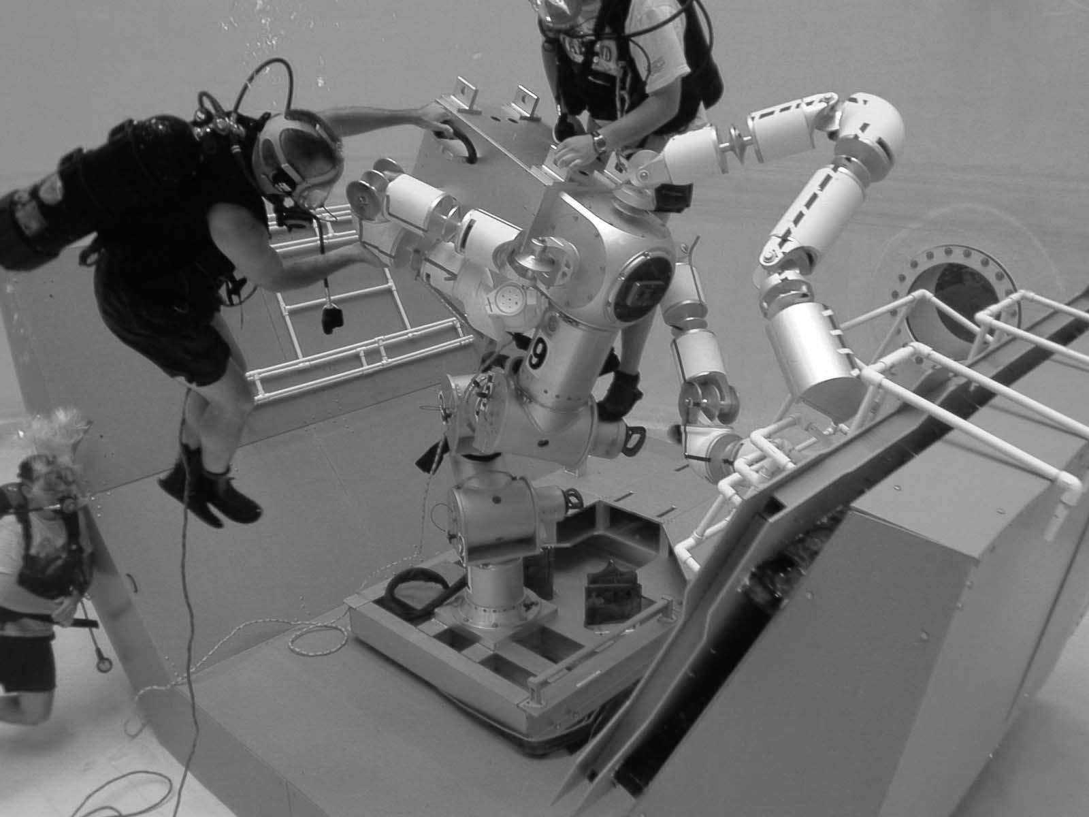
Figure 2: Ranger EVA mockup on a NBRF Spacelab pallet.

The manipulator arms are exact duplicates of the flight arms, except for joint seals and different surface finishes. The dexterous manipulator suite consists of two eight-joint “dexterous” manipulators for carrying out servicing tasks and a seven-joint “video” manipulator for visual surveillance. The dexterous manipulators are 5.5 inches in diameter, 48 inches long and capable of at least 30 lbs of force and 30 ft-lbs of torque at the tool tip. A set of seven, interchangeable end-effectors are available for performing the various tasks and are mounted on tool posts at the aft end of the body. The video arm is based on the dexterous design, but uses a 3-axis wrist equipped with a stereo camera instead of a dexterous wrist. This arm is 55 inches long for greater reach for better camera angles. The first dexterous wrist began run-in testing in mid-October 2001.
The six-joint “positioning leg” (PXL) is 106 inches long and capable of outputting 25 lbs of force and 225 ft-lbs of torque at the either end. It has active brakes and can hold a 250 lb load applied at full extension. Since the PXL must support the entire robot during orbiter induced, on-orbit loads, the link segment diameter is 10 inches to increase stiffness. A pitch joint of the PXL underwent run-in testing in October 2001.

Surface Support Equipment
The surface equipment consists of the electrical power system, the pneumatic system, and data relay. The flight robot uses 28 VDC for the control bus and 48 VDC for the actuator bus. NBRF safety requirements limit submerged DC voltages to 32 VDC. Two separate power supplies provide 28 VDC & 32 VDC with voltage isolation and current limiting. An air console regulates RNBV II’s three pressure volumes: the robot body, the head and arms, and the positioning leg. SCUBA cylinders supply air between 3000 and 500 psi to first stage regulators. They output air at 125 psi down to the robot through the umbilical. Second stage regulators near the robot foot maintain the robot at 3-6 psi above ambient pressure. Data and video signals are sent from the robot to the surface equipment along the umbilical. These signals are electrically isolated and forwarded to the control station for processing. RNBV II also has a leak detection system not found on the flight unit.

Spacelab Logistics Pallet (SLP)
The SLP provides hard points for mounting heavy experiment equipment. The pallet is approximately 9 feet is length and 12 feet in width. An neutral buoyancy version of the SLP and orthogrid secondary structures, see in Figure 2 and constructed from fiberglass, replicates the form and fit of the flight unit and provides mounting locations for the PFSS and task equipment.

Ground Control Station
The Space Systems Lab control room in the NBRF duplicates all the functions of all control stations planned for RTSX flight and ground use. This facility can control a variety of lab robotic systems, including Ranger NBV I. During the flight, the telemetry relayed from the orbiter will allow RNBV II to simulate the motions of the flight vehicle. RNBV II and NBRF control room can also be used for contingency procedures development both before and during the shuttle flight.
The Flight Control Station, shown in Figure 3, allows one operator to control any of the four manipulators on Ranger. Located in the Shuttle's middeck, the astronaut crew will use a pair of three-axis hand controllers to control the position and orientation of the robot and arms. Three video monitors allow the operator to switch from different camera angles to assist them in their task. A Silicon Graphics O2 computer sends the appropriate commands and displays system telemetry on a monitor. A functional equivalent of the flight control station exists on the ground and will be used to develop single operator control techniques required for flight.
The Ground Control Station, illustrated in Figure 4, is not limited to a single operator or computer to control Ranger. Two operators can work in tandem controlling the manipulators cooperatively, while support personnel use monitoring stations to examine system parameters or diagnose vehicle contingencies. These monitoring stations require a computer linked to the Internet with the proper software client. Graphical simulations assist operators in visualizing the vast telemetry coming from the vehicle. Multiple input devices, including three-axis joysticks, three-dimensional position trackers, mechanical mini-masters, and force balls can be used to control a manipulator.

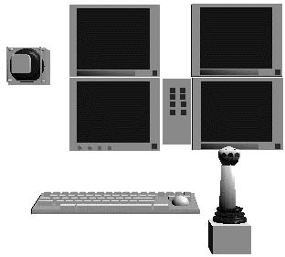
Figure 3: Flight Control Station Layout.
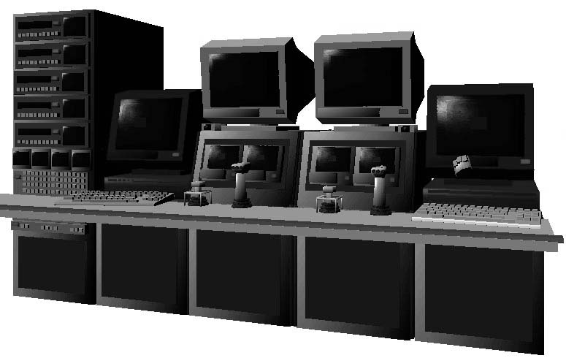
Figure 4: Ground Control Station Layout.

The goal of the ground control station is to allow the operator(s) to use natural intuitive movements to control Ranger. The operator can have input devices in each hand, and as they move their hands the robot arms track that same motion. Three-dimensional displays give the operator stereo vision, important when performing manipulation tasks. With more processing capability on the ground, virtual reality concepts like predictive displays and information visualization of telemetry can be displayed in a virtual environment. The ground control station, flight control station, and the flight control station ground trainer completed integration in October 2001.

OPERATOR INTERFACE AND SOFTWARE DEVELOPMENT
This section discusses the development of the operator interface and software development for Ranger TSX. The two primary operator interfaces, operations and engineering, are described, and the staged software development for the project is outlined.

Operator Interfaces
Two styles of control station interfaces are available to the operator(s). The Operations Interface, shown in Figure 5, was designed around an operator focused more on the live video feeds and the use of input devices rather than telemetry panels. This interface is structured around brightly color status boxes to give the operator a quick sense of the vehicle state. Additional information is provided with quick tabs, which places the details in fixed tiled locations. A tiled window placement was found to improve performance with quick window access with no window obstructed⁸. The operator primarily uses the hand controllers to move manipulators, and only uses the interface for changing control modes and selecting which arm to operate.
The Engineering Interface, shown in Figure 6, provides greater control and monitoring capabilities. About 100 different windows are available to view any aspect of the robot. The operator can organize any number of these windows to make a custom virtual cockpit⁹. Quick window reconfiguration allows an operator to use their preferences to create a control station focused on the details to control a particular arm, and then switch to monitor voltages, currents, and temperatures of vehicle. An additional application, the Data Monitor, allows monitoring of every command and all telemetry passed between control stations and the vehicle. The operator can quickly construct dynamic graphs and charts to assist them in diagnosing any anomaly on the vehicle or control station.
The design of the Engineering Interface is complete and is in coding. The Engineering Interface will assist in the final development of the Operations Interface, still in the design phase. The Data Monitor complete and used in testing and developing the other interfaces.

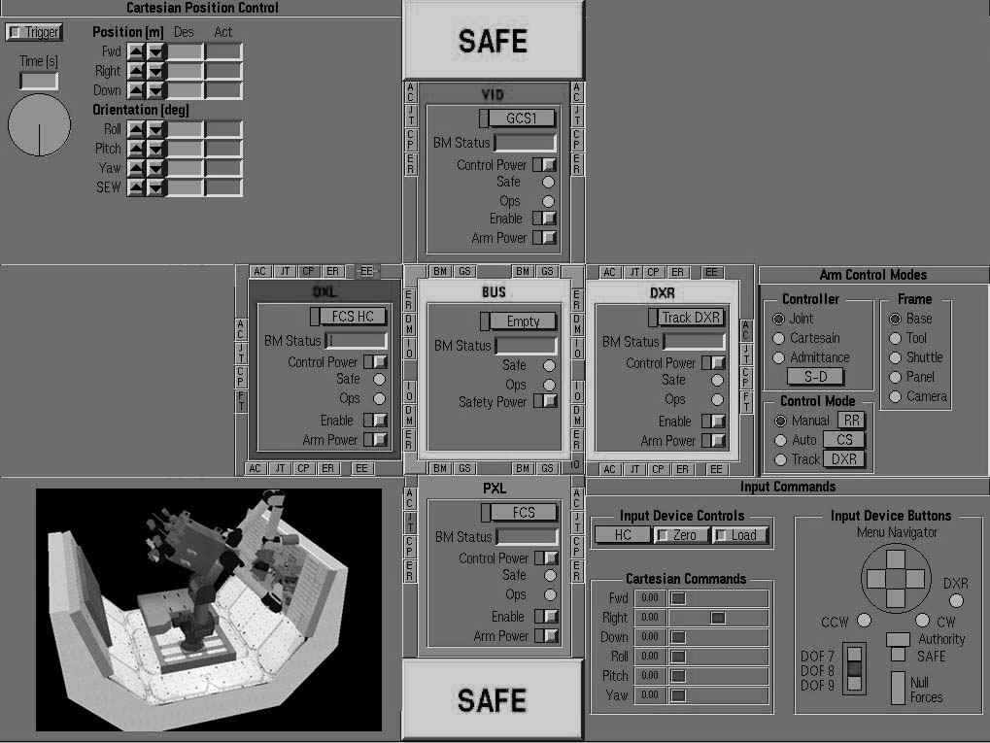Figure 5: Operations Interface
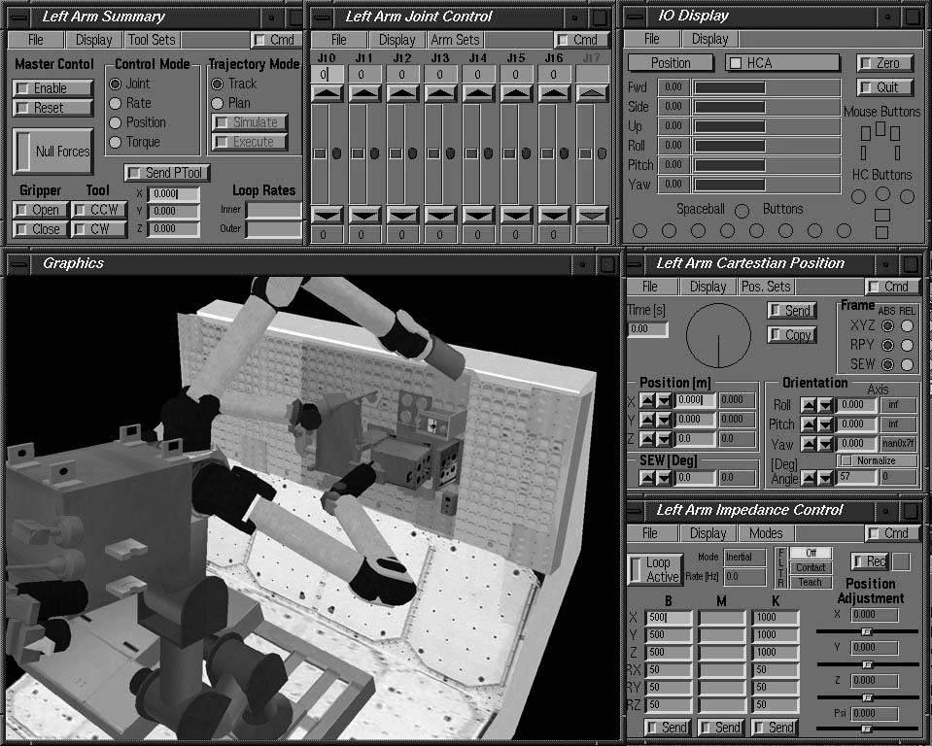 Figure 6: Engineering Interface

Software Development
Software development for Ranger TSX is divided into code residing onboard the vehicle and code driving the operator interface on the flight and ground control stations¹⁰. The onboard code consists of VxWorks modules for control, communications, and telemetry. Up to three controllers are available for each arm ranging from direct joint control for calibration and checkout to admittance control for arm operations requiring compliance at the end-effector^{11,12}. Almost all of the control code and libraries evolved from versions developed for Ranger NBV I. The control code is rewritten for compatibility with a new communication protocol and symbol table structure.
Several control stations are interconnected with the vehicle to provide the operators an effective tool for controlling and monitoring the many systems on Ranger. Each control station module uses a hybrid UDP/TCP communication protocol to communicate with the other modules across a LAN, the Internet, or the OCA communication system between the Shuttle and JSC. Figure 7 illustrates many of the control software modules that work together. Each large shaded box represents a different physical location, which runs different software¹³.

The hybrid UDP/TCP protocol allows the system to gain the benefits of both systems. Several commands are continuously streamed to control the manipulator; using UDP these messages are delivered quickly and efficiently. However, several safety related commands require the more reliable transmission that TCP provides. Although multiple control stations can exist, a command authority checker is embedded into the communication protocol. This allows multiple control stations to break down the workload, while ensuring only one operator has the ability to send commands to each subsystem. This not only facilitates single operator control, but also provides a way for multiple operators located in different areas to collaborate on controlling Ranger. For example, all control stations can monitor vehicle telemetry, but only the Flight Control Station controls the left arm, the Ground Control Station commands right and video arms, and another station elsewhere could send commands to the bus system.
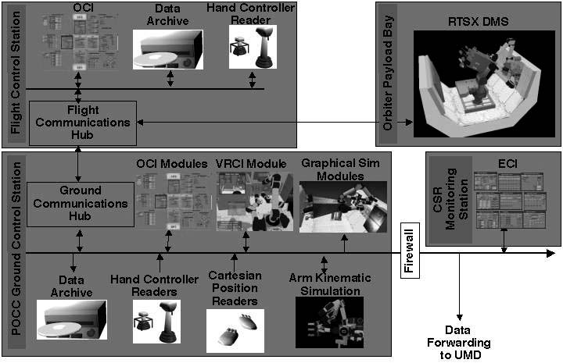
Figure 7: Networked Control Station Processes.
The software development implements a staged development cycle¹⁴ as shown in Table 1. The initial stages provide the most critical functionality with latter stages providing successive increments of functionality. Each stage must reach the flight release level before certification for flight. There are a small number of stages, typically with a number of minor builds between them. Each minor build incrementally adds functionality until the stage's functionality is acquired.
Table 1: Staged Development Cycle.
Stage | Summary description | Content outline
A | Provides local control of one dexterous wrist LPU, with five actuators and a force-torque sensor | LPU
B | Provides user control, involving entire communications system, of one dexterous wrist LPU, with five actuators and a force-torque sensor | Single string communications : CS-DMU-LPU
C | Provides engineering control of one arm executing tasks without boundary management and a Monitor DMU | FCS + FCH + ECI + DMU + LPUs + One arm control
D | Provides engineering control of two arms executing tasks without boundary management and a Monitor DMU with calibrated force torque data | + Two arm simultaneous control + calibrated force-torque data
E | Provides engineering control of two arms executing tasks without Monitor DMU, with BM for RPCM and ECU only, and with a trajectory planner | + ECU + RPCM + Trajectory planner
F | Provides on-orbit and ground engineering control of two arms executing tasks without Monitor DMU, with BM for RPCM and ECU only, with a trajectory planner and impedance control | + GCS + GCH + Impedance control
G | Provides on-orbit and ground, operational and engineering control of two arms executing tasks without Monitor DMU, with BM for all ORU tasks, with a trajectory planner and impedance control | + OCI + APFR

Stages A and B are complete, and Stage C begun in August 2001. Stage A provided local control (i.e. by a TestPC connected via 1553) of one dexterous wrist local processing unit (LPU), with five actuators and a force-torque sensor. Stage B is a user controller involving the entire communications system of one LPU controlling five actuators. Stage C will provide engineering control of one arm executing tasks without boundary management or Monitor DMU, and is scheduled for the end of the 2001.

TEST OPERATIONS
Current operations to support the RTSX mission include buildup and testing of the Ranger NBVII manipulator arms, dive operations with the Ranger EVA mockup, and simulated RNBVII testing with Ranger NBVI.

Manipulators
The assembled dexterous wrist is shown in Figure 8. Electronics, which drive the four wrist joints and two tool drives, are located in the forearm shown on the left. An interchangeable end-effector mechanism for rapid, secure tool changeout is shown installed on the hand roll joint to the right. A force-torque sensor is mounted at the interface between the wrist and link housing. The elbow and shoulder links are currently in fabrication and assembly will commence once the wrist axes electronics have been integrated and tested.
A pitch joint of the positioning leg is shown undergoing a break-in test in Figure 9. The drive electronics, housed in the hub shown on the left side of the pitch joint, use the same design as the dexterous arms. The brake is mounted concentrically to the hub in the middle of the joint axis. A roll joint (shown at the base) will be tested in the next phase. The roll and pitch joints throughout the leg use a common design to reduce development time and mechanical integration.

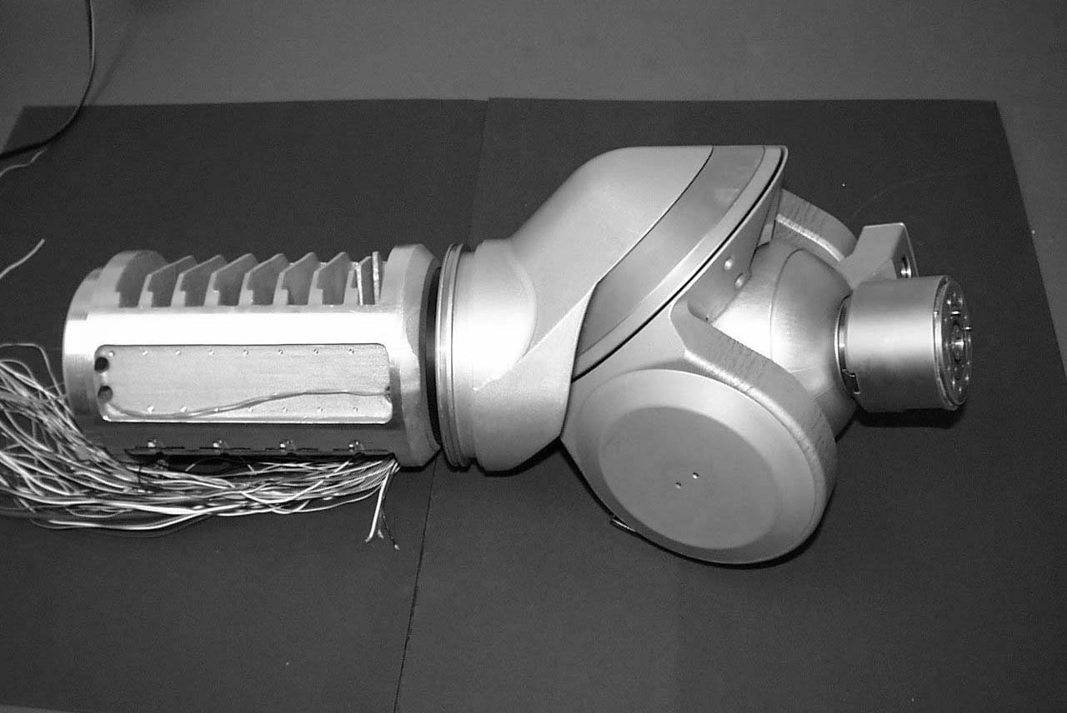
Figure 8: Dexterous wrist awaiting electronic integration.
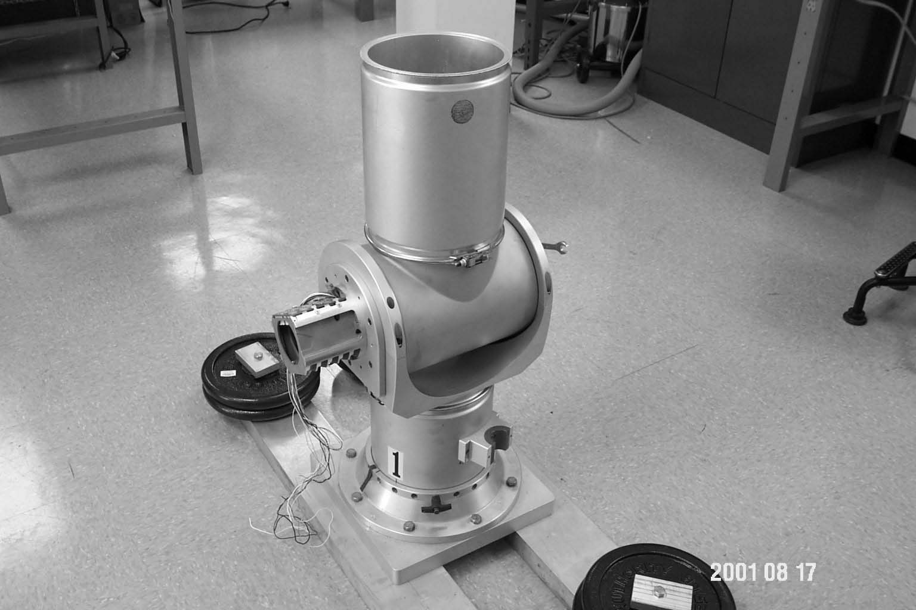
Figure 9: Joint 2 of positioning leg undergoing servo testing.

Ranger EVA Mockup
A medium-fidelity, functional mockup of the flight robot, REVA, was completed in April of 2000. The mockup, shown in Figure 2, has over 62 hours of underwater test time on 45 separate dives. This mock-up assists in the finalization of the hardware design as well as EVA contingency planning and evaluation. It has the same kinematic configuration as the flight vehicle, but has no onboard electronics. Because its primary role is as a neutral buoyancy trainer for (EVA) crewmembers, it is as neutral as possible so that much of the material selection differs from that of the flight robot. It will be used at JSC for use in the Neural Buoyancy Laboratory to train astronauts in contingency EVA release and stow procedures.

Ranger NBV I
In spring 2001, a test used RNBV I to simulate RTSX tasks and provide preliminary data until RNBVII becomes operational. RNBV I was retrofitted with an interface plate so it could attach to the REVA leg mockup. The mockup PXL was manually maneuvered to different configurations so the RNBV I dexterous arms could reach the task panel (Figure 10).

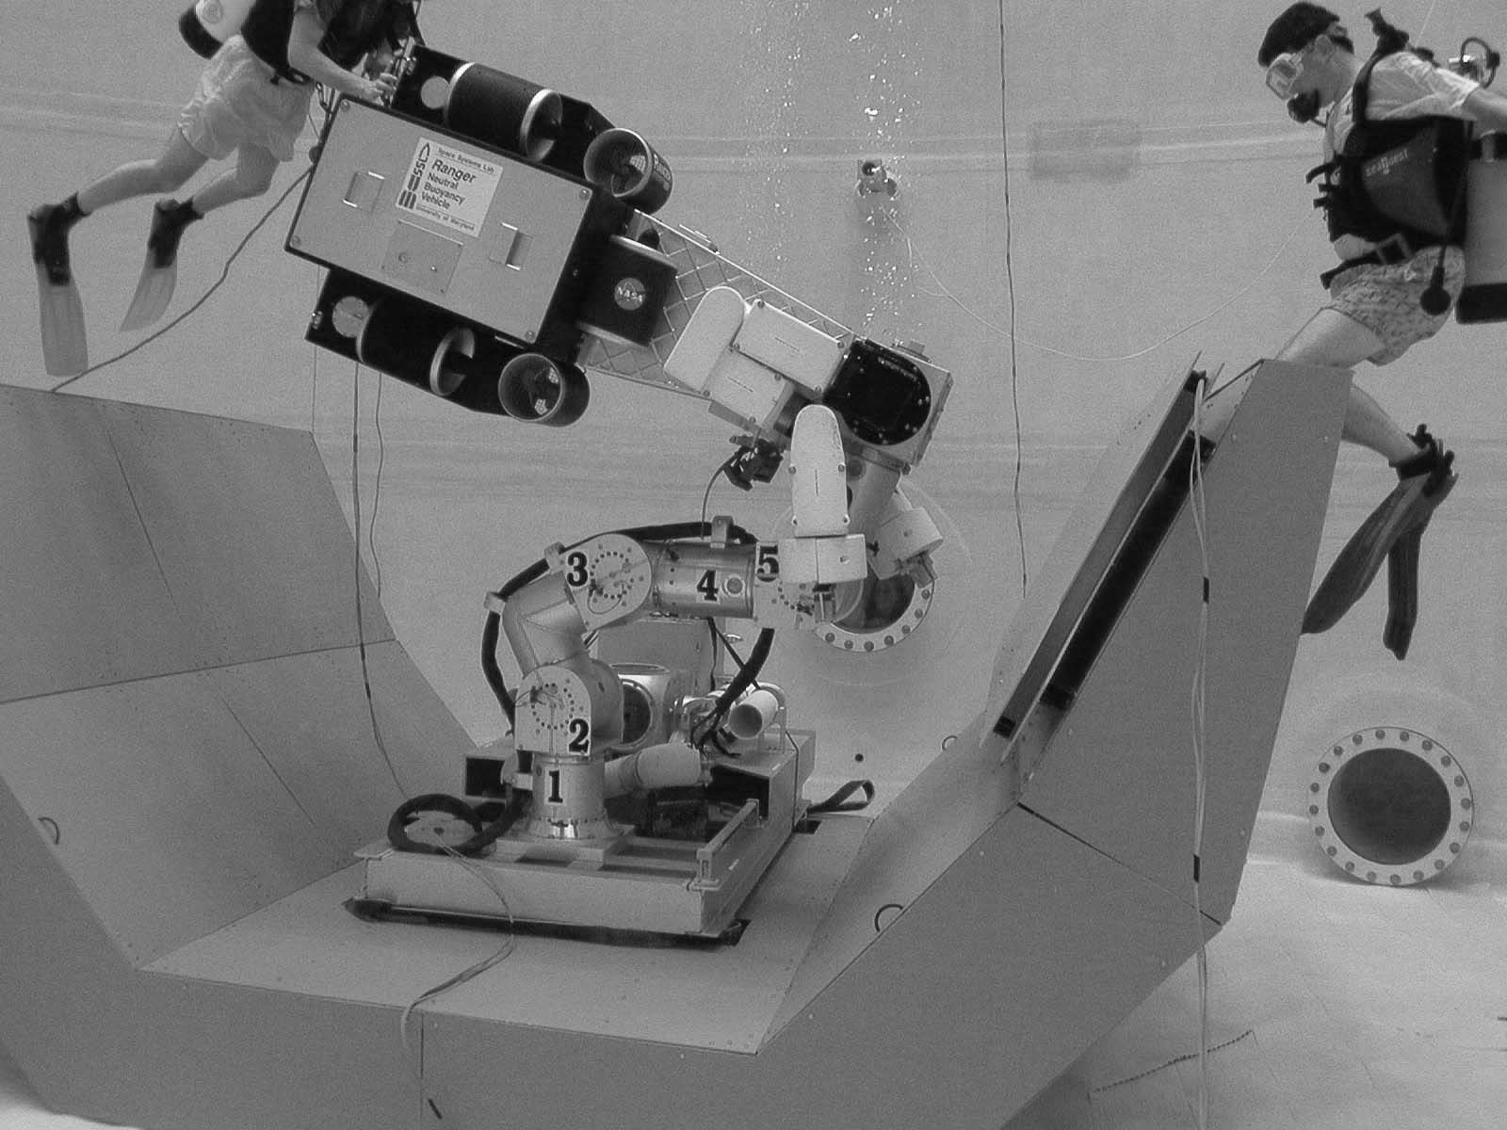
Figure 10: Ranger NBV I attached to the PXL/PFSS section of the REVA mockup.
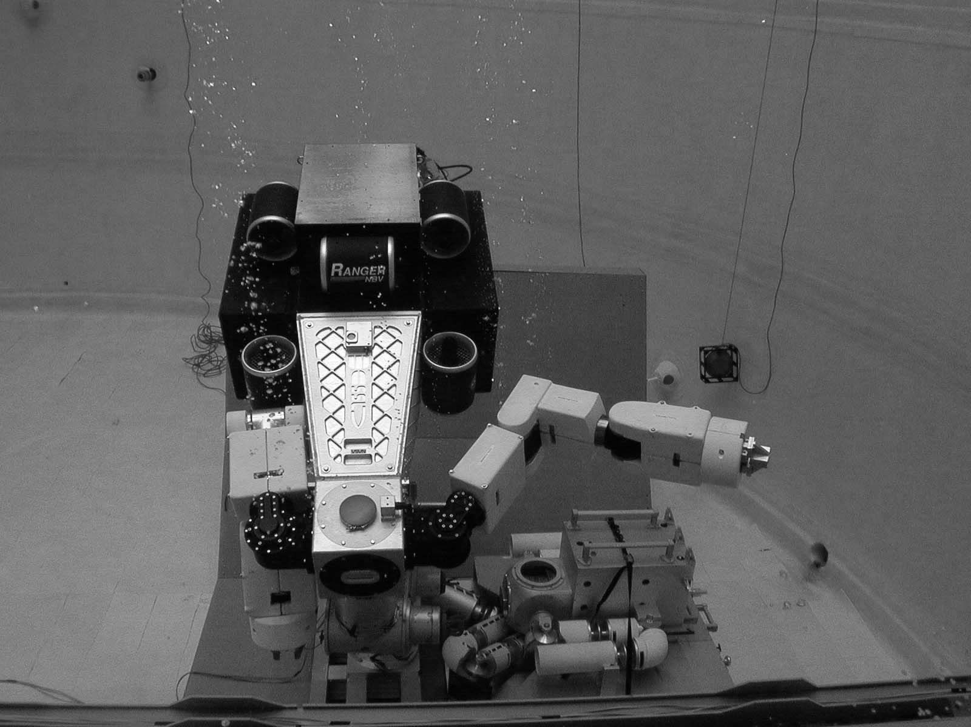
Figure 11: Ranger NBV I deploys left dexterous arm.

STATUS AND OUTLOOK
The RTSX program changed serial development process in light of the high uncertainty of Space Shuttle manifest opportunities starting in May 2001. RNBVII is in integration, and should achieve first systems operation in neutral buoyancy in January 2002. The flight article is 75% procured, and final procurement and integration will commence upon completion of NBV II verification (or sooner if an earlier launch opportunity becomes available). RTSX completed its Phase 2 Payload Safety Review with the Space Shuttle Program in December 1999. Further safety reviews depend on formal manifest. Payload Operations Working Group meetings with Johnson Space Centers Mission Operation Directorate are continuing.
Ranger shuttle manifest status is on hold, as is true of most science payloads. RTSX is currently the number one shuttle cargo bay experiment for NASA’s Office of Space Science, and number two in the integrated Space Shuttle Program’s cargo bay priority list. The large cost overrun of the International Space Station Program announced in January 2001, and general lack of congressional or presidential desire to increase NASA’s budget, have put a significant squeeze on manifest slots for non-ISS payloads. This situation is unlikely to improve until at least 2006.
The future of RTSX is two-fold. The RNBV II vehicle begins operations in early 2002, and will start to produce the ground database portion of robotic task completion data in late Spring 2002. It will be a useful telerobotic tool for the Space Systems Laboratory for several years. The flight experiment component can proceed at any time, but is held for lack of formal manifest. If, as it currently appears, a shuttle manifest is not available before 2004, then it is highly unlikely that Ranger will fly in its current form. The program will need to go on “pause” for several years until the science manifest situation improves. By then, the climate may require retooling Ranger to meet the robotic needs in the future.
Robots may be a permanent ISS or other platform-based robot, or a free-flying system capable of satellite servicing and/or repair. Next/Next Generation Space Telescope and the Air Force’s Space Based Laser both are seriously considering robotic servicing as a necessary, enabling technology. A successful RTSX shuttle mission would greatly improve the chances of follow on Ranger or Ranger-type mission.

ACKNOWLEDGEMENTS
The Ranger Telerobotic Flight Experiment (NCC5-243) is funded by the Space Telerobotics Program of the NASA Headquarters Office of Space Sciences, Advanced Technology and Mission Studies Division (Code SM). The authors wish to acknowledge all of the members of the Ranger Team who have contributed to the program and materials used in this report and to our Program Executive, Joe Parrish, of NASA Headquarters.

REFERENCES
- J. C. Parrish, “The Ranger Telerobotic Flight Experiment: A teleservicing system for on-orbit spacecraft,” in Telemanipulator and Telepresence Technologies III, M. R. Stein, ed., Proceedings of the SPIE 2901, pp. 177-185, 1996.
- J. C. Parrish, “The Ranger Telerobotic Shuttle Experiment (RTSX): Status Report,” ,” in Telemanipulator and Telepresence Technologies IV, M. R. Stein, ed., Proceedings of the SPIE 3206, pp. 189-197, 1997.
- J. C. Parrish, “The Ranger Telerobotic Shuttle Experiment (RTSX): Status Report,” ,” in Telemanipulator and Telepresence Technologies V, M. R. Stein, ed., Proceedings of the SPIE 3524, 1998.
- J. C. Parrish, B. R. Sullivan and B. J. Roberts, “Planning for the Ranger Telerobotic Shuttle Experiment On-Orbit Operations”, AIAA Space 2000, AIAA 2000-5291, Long Beach, September 2000
- B. R. Sullivan and D. L. Akin, “A Survey of Serviceable Spacecraft Failures”, AIAA Space 2001 Conference and Exposition, Albuquerque, August 2001
- J. C. Lane, C. R. Carignan, and D. L. Akin, “Time Delay and Communication Bandwidth Limitation on Telerobotic Control,” Mobile Robots XV and Telemanipulator and Telepresence Technologies VII, Proc. of SPIE Vol. 4195 (2001), Boston, November 2000
- J. C. Lane, C. R. Carignan, D. L. Akin, “Advanced Operator Interface Design for Complex Space Telerobots,” Autonomous Robots 11, Kluwer Academic Publishers, pp. 49-58, 2001
- J. C. Lane, S.P. Kuester, and B. Shneiderman. "User Interfaces for a Complex Robotic Task: A Comparison of Tiled vs. Overlapped Windows". Computer Science Technical Report CS-TR-3784, ISR-TR-97-55. University of Maryland. 1997.
- J. C. Lane, C. R. Carignan, and D. L. Akin, “Reconfigurable Control Station Design for Robotic Operations”, Proceedings of the IEEE International Conference on Systems, Man, and Cybernetics, Orlando, October 1997
- C. R. Carignan, J. C. Lane, and D. L. Akin, “Controlling Robots On-Orbit,” Proceedings of the IEEE International Symposium on Computational Intelligence in Robotics and Automation Conference, Banff, Alberta, Canada, July 2001
- C. R. Carignan and D. L. Akin, “Obtaining Impedance Objectives in Robot Teleoperation”, Proceedings of the IEEE International Conference on Robotics and Automation, Albuquerque, April 1997
- C. R. Carignan, D. L. Akin, and J. C. Lane, “Dynamic Tool Vectors for Robo-Centric Control,” Proceedings of the IEEE International Conference on Robotics and Automation, San Francisco, April 2000
- C. R. Carignan, J. C. Lane, and D. L. Akin, “Control Architecture and Operator Interface for a Free-Flying Robotic Vehicle,” IEEE Transactions on Systems, Man, and Cybernetics Part C: Applications and Reviews, Vol. 31C, No. 3, Aug. 2001
- S. R. Roderick, “Ranger Telerobotic Shuttle Experiment Staged Delivery Plan”, DT07-9002, Space Systems Laboratory, University of Maryland, College Park, June 2001

